 | Epsom & Ewell F.C.  13  v  Balham F.C.  Saturday, 20th January 2018 – 3.00 p.m.
Good afternoon and welcome to High Road for our League match against Balham. We welcome their players, supporters and officials on their first ever visit and wish them a safe journey home, as of course we do for our own regular supporters.

Balham are new to our Division but are holding a steady position in the League table and do not appear to have any concerns this season. We have of course only met once before and that was back in November where we started well, but after conceding to a superb long range strike just before half time we fell away in the second period to lose 4-0 in a match played at Colliers Wood United where they currently ground share.

It goes without saying that this is an extremely important League match for our boys. The win at Godalming Town was a great result but we need to follow that up with some more positive results. It’s a tough challenge but this match and the following one here in three days against Abbey Rangers present us with an opportunity we need to take. We wish our players and of course our new Management staff the best of luck in those matches.

For those who do not follow us on Social Media and weren’t at the game on Tuesday our club parted company with Glyn Mandeville on Saturday evening and Neil Grant has stepped up from his role as Coach and is our new Caretaker Manager. We’ll bring you more news about the new man in charge in the SCR programme on Saturday 3rd February, but in the meantime also welcome his new Player/Coach Jordan Clark to High Road, while Alex McKay remains as Assistant Manager.

We were last here just four days ago when we faced an extremely tough challenge from Isthmian League Premier Division Merstham and although they won 5-0, I thought it was a spirited display from our boys who fought all the way. The gap between Step Three and Step Five has maybe never been greater and it was always going to be a difficult challenge.

We have one fixture change to advise for later in the season. Those planning to watch our boys at Walton & Hersham’s new ground at the Elmbridge Sports Hub on Saturday 21st April will have to wait three more days as their joint tenants Walton Casuals also have a home match that day, so we will visit on Tuesday 24th April for what is currently our final away match of the season.

Thanks to all of you that have purchased our Centenary merchandise. It is available now and so if you would like to pass our Chairman your money he will let you have your special delivery!

Enjoy the game!

Rich

Don’t forget, you can now follow us on Social Media. Please see the inside cover for addresses.

Cover photos by Gemma Jarman

- Marlon Pinder heads the winning goal at Godalming on his debut
- The old guard and the new – our former and current Managers at Godalming
1

Cherry Red Records Combined Counties League
Premier Division Table 2017/18
inc Weds 17th January | P | W | D | L | F | A | Pts | GD | H | A
Westfield | 23 | 20 | 1 | 2 | 79 | 23 | 61 | +56 | 14/4 | 0-5
Bedfont Sports | 26 | 18 | 4 | 4 | 70 | 34 | 58 | +36 | 24/3 | 0-7
Walton & Hersham | 27 | 17 | 6 | 4 | 60 | 30 | 57 | +30 | 0-2 | 24/4
Sutton Common Rovers | 26 | 17 | 3 | 6 | 55 | 31 | 54 | +24 | 3/2 | 0-5
Camberley Town | 26 | 9 | 14 | 3 | 35 | 27 | 41 | +8 | 10/3 | 1-1
Hanworth Villa | 26 | 10 | 7 | 9 | 47 | 52 | 37 | -5 | 1-1 | 10/2
Horley Town | 23 | 11 | 4 | 8 | 37 | 44 | 37 | -7 | 2-3 | 2-3
CB Hounslow United | 24 | 11 | 3 | 10 | 40 | 32 | 36 | +8 | 13/2 | 2-4
Spelthorne Sports | 25 | 10 | 6 | 9 | 43 | 36 | 36 | +7 | 1-5 | 27/1
Knaphill | 25 | 9 | 8 | 8 | 45 | 47 | 35 | -2 | 24/2 | 2-6
Guildford City | 26 | 10 | 5 | 11 | 46 | 51 | 35 | -5 | 1-3 | 7/4
Balham | 21 | 9 | 5 | 7 | 39 | 35 | 32 | +4 | 20/1 | 0-4
Redhill | 25 | 9 | 4 | 12 | 41 | 41 | 31 | 0 | 0-5 | 0-3
Abbey Rangers | 22 | 8 | 5 | 9 | 36 | 35 | 29 | +1 | 23/1 | 17/2
North Greenford United | 22 | 7 | 7 | 8 | 38 | 38 | 28 | 0 | 1-2 | 17/3
AFC Hayes | 22 | 7 | 4 | 11 | 32 | 39 | 25 | -7 | 28/4 | 0-2
Chertsey Town | 25 | 7 | 3 | 15 | 43 | 56 | 24 | -13 | 2-7 | 0-1
Farnham Town | 25 | 5 | 6 | 14 | 31 | 47 | 21 | -16 | 3-0 | 0-0
Banstead Athletic | 23 | 5 | 6 | 12 | 30 | 55 | 21 | -25 | 2/4 | 1-1
Colliers Wood United | 23 | 5 | 4 | 14 | 37 | 47 | 19 | -10 | 30/3 | 2-5
Godalming Town | 24 | 4 | 5 | 15 | 26 | 54 | 17 | -28 | 0-3 | 2-1
Epsom and Ewell | 25 | 2 | 4 | 19 | 23 | 79 | 10 | -56 | X | X
1

Lucky Day? – 20th January
Played 12 - Won 4 Drawn 0 Lost 8 - For 13 Against 30 - PPG 1.00 - Poor
Our Club record against today’s opponent
Played 1 - Won 0 Drawn 0 Lost 1 - For 0 Against 4 - PPG 0.00
Our Largest wins and losses against today’s opponent
No win yet!
25th November 2017 - Lost 0-4 - Combined Counties League (A)
Their Last Visit
Balham have never previously visited us

Recent Results and Fixtures
Surrey Senior Cup – Tuesday 16th January 2018
Epsom & Ewell | 0-5 | Merstham
Combined Counties League – Tuesday 16th January 2018
Walton & Hersham | 1-1 | Knaphill
Combined Counties League – Wednesday 17th January 2018
Colliers Wood United | p-p | Godalming Town
Combined Counties League – Saturday 20th January 2018
Banstead Athletic | V | Sutton Common Rovers
Bedfont Sports | V | Spelthorne Sports
Camberley Town | V | Hanworth Villa
Chertsey Town | V | Knaphill
Colliers Wood United | V | Abbey Rangers
Epsom & Ewell | V | Balham
Farnham Town | V | Godalming Town
Guildford City | V | Walton & Hersham
North Greenford United | V | Horley Town
Redhill | V | CB Hounslow United
Westfield | V | AFC Hayes
Combined Counties League – Monday 22nd January 2018
Sutton Common Rovers | V | Cobham
Combined Counties League – Tuesday 23rd January 2018
AFC Hayes | V | Chertsey Town
Bedfont Sports | V | Westfield
Epsom & Ewell | V | Abbey Rangers
Combined Counties League – Wednesday 24th January 2018
Balham | V | Horley Town

Did You Know?
On Saturday our excellent 2-1 win at Godalming Town broke a horrible run of away League results. It was our first away League win since a 2-1 win at Horley Town on Easter Monday 17th April, which was 15 matches or 271 days ago. But is it a record?

The answer is no, but it was our worst run since 1986/87 when we also went 15 matches between wins but over a longer period of time, 298 days between a 3-2 win at Farnborough Town and a 3-0 win at Staines Town.

Of course, the actual length of time between wins can be skewed by the three months of summer so let’s look at the number of matches. The run of 15 matches was last beaten in our relegation season of 1985/86 when we went 18 matches before winning 3-2 at Worthing.

So what is the club record? From 5th March 1949 until 26th January 1952 we didn’t win a single away League match, a span of 38 matches or 1,057 days. Let’s hope we never break that particular record!

From behind the goal
Epsom & Ewell 0-5 Merstham
Surrey Senior Cup – Second Round - Tuesday 16th January 2018

Merstham ease to victory on Grant's debut

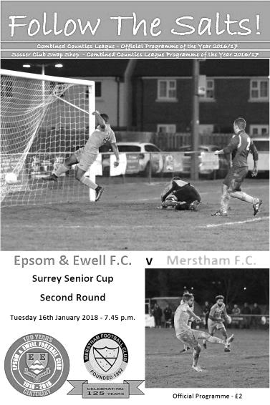
Way back in 1965 Epsom & Ewell and Merstham met for the very first time, with our club coming away from the tiny Surrey Senior League venue, then based at Albury Road, with a comfortable 5-0 victory. Fast forward 52 years and with that League now known as the Combined Counties League, the positions were completely reversed as an impressive Merstham side eased to a comfortable victory at High Road.

This is not an indication of how Epsom have fallen as a club, particularly over the last thirty years, it is more an acknowledgement of Merstham's success over that time. It's ten years now since they dominated our League and moved up to the Isthmian League, but their success continues unabated and in a competition that they have claimed three times in the last ten years, they were not going to take chances with an Epsom side under the Management of Neil Grant for the first time and did us the honour of fielding a very strong team.

With Ashley Thompson injured, Rob Hendry ill, Alistair Turpie unavailable and Marlon Pinder and Endrit Dobraj cup tied, Kane Grandison, Ben Dyson, Liam Roberts, Conor Young and Reisse Griffin came into the starting eleven following our win at Godalming Town three days previously and we kicked off in front of a disappointing crowd of just 86, although admittedly it was a bitter evening.

It's a very positive sign that we competed with them as equals for the first twenty five minutes of the match. Our skipper Alex McKay, nearing the 200 appearance mark for the club, was in action early, intercepting a dangerous ball in just in front of Conor Young, but in the 10th minute we were unfortunate not to take the lead ourselves as Kyen Nicholas held the ball up and teed up Lloyd Connelly, whose curling effort from 20 yards just clipped the bar of Chris Haigh's goal.

One of the key battles of the night came on the Merstham right flank where their flying winger Alex Addai and our own Reisse Griffin had a terrific battle throughout, despite our man being better suited to our right hand side. Inevitably though, the Isthmian League Premier Division outfit began to take charge of matters and in the 26th minute their first real shot in anger was deflected wide for a corner, from which a header was

planted onto the roof of our net. Three minutes later though they were ahead as their right winger finally managed to get past Griffin and his low near post cross was clipped across Young into the net by Tayshan Hayden-Smith.

Young was in action soon after this as a left wing cross was met by an unmarked header, but was able to tip it over the bar. Unfortunately in the 36th minute we conceded again as a left wing cross was deflected into the path of the incoming Sean Bonnett-Johnson who finished clinically from close range. In truth the visitors had further chances as the half came to the close with Young making some more saves, but in first half injury time Ben Dyson made space on the left and sent a perfect cross into the box but our young defender Noah Stew-Lewis maybe didn't realise how much time he had and ducked into the header a little, sending it over the bar from 12 yards out.

The second half continued to take a similar pattern with Merstham doing the majority of the pressing. Despite our decision to keep quite a high line to compress their midfield, we were still treated to a passing masterclass which only highlighted the standard between the two steps of football nowadays. It was one of those days where you wished you could have met them on a ploughed field, instead of the excellent Chipstead surface. They thought they had scored in the 62nd minute when a deep cross from the left was finished off from close range by Addai, although it was disallowed by a late flag. It seemed a bit late for an offside call though and it actually transpired that Addai had used his hand, for which he received a yellow card.

We made a couple of substitutions as Adam Heagney limped off and Nicholas was withdrawn with an eye on Saturday's important League match with Balham and Scott Murphy was on target with a low drive from twenty yards, but after half an hour of good work, we then conceded three times in the final thirteen minutes to leave a slightly harsh scoreline as we tired. The third goal after 77 minutes came with a fairly straight pass through our defence where Tom Collins just got his toe to the ball ahead of the advancing Young, leaving him an empty net. Four minutes later Addai turned provider again with a strong run and cut back for substitute Alberto Lubango to knock in from close range, and six minutes later Lubango scored the goal of the night with a curling effort into the far corner from around 20 yards.

It was an unfortunate ending, but there were many positives to take from this match against a team that will quite probably be favourites to win this competition again. We never gave up, competed throughout and as our new Manager confirmed to me after the match, there are still more players expected to join the ranks with 26 attending training last Thursday. The present might be a bit disheartening if you look at the League table right now, but the future appears bright.

Epsom and Ewell: Conor Young, Noah Stew-Lewis, Reisse Griffin, Adam Heagney,
Alex McKay (c), Kane Grandison, Liam Roberts, Scott Murphy, Kyen Nicholas,
Ben Dyson, Lloyd Connelly

Subs: Samuel Marks for Heagney (63) Germaine Jeannoel for Nicholas (65)

Club Records - 20th January
Date | Day | Competition |  | Opponents |  | Scorers
20/01/34 | Sat | Surrey Senior Cup 1 | A | Dulwich Hamlet | 0-3
20/01/51 | Sat | Corinthian League | A | Tilbury | 1-3 | S.Faggetter
20/01/62 | Sat | Corinthian League | A | Edgware Town | 0-4
20/01/68 | Sat | Athenian League 2 | H | Rainham Town | 0-5
20/01/73 | Sat | Athenian League 2 | A | Uxbridge | 0-2
20/01/79 | Sat | Isthmian League 1 | A | Harwich & Parkeston | 1-5 | T.Tuite (pen)
20/01/90 | Sat | Isthmian League 2s | H | Petersfield United | 2-1 | C.Hadingham (2)
20/01/96 | Sat | Isthmian League 3 | H | Harefield United | 2-0 | A.Boxall (2)
20/01/04 | Tue | Isthmian League 1s | H | Windsor & Eton | 2-4 | A.Stones, L.Purvis
20/01/07 | Sat | Combined Counties  Premier Division | H | Bedfont | 1-0 | A.Myers
20/01/09 | Tue | Surrey Senior Cup 3 | H | Redhill | 3-0 | J.Keys, K.Hough (2)
Historical Decades
Date | Day | Competition |  | Opponents |  | Scorers
90 years ago – Epsom Town F.C.
21/01/28 | Sat | London League | H | Mitcham Wanderers | 2-1 | R.Marlow, W.Challis
80 years ago – Epsom F.C.
22/01/38 | Sat | Surrey Senior Cup 1 | H | Met Police | 4-1 | T.Rochester (2), J.Jones, B.Beglan
70 years ago – Epsom F.C.
24/01/48 | Sat | London League | A | Edmonton Borough | 1-7 | T.Rochester
60 years ago – Epsom F.C.
25/01/58 | Sat | Corinthian League  Memorial Shield 2 | H | Maidenhead United | 5-0 | J.Bangs (3), D.Hermitage, P.Freeman
50 years ago – Epsom & Ewell F.C.
20/01/68 | Sat | Athenian League 2 | H | Rainham Town | 0-5
40 years ago – Epsom & Ewell F.C.
21/01/78 | Sat | F.A. Vase 4 | H | Eastbourne United | 0-3
30 years ago – Epsom & Ewell F.C.
23/01/88 | Sat | Isthmian League 2s | A | Met Police | 1-1 | S.Ireland
20 years ago – Epsom & Ewell F.C.
24/01/98 | Sat | Isthmian League 3 | A | Ware | 3-2 | A.Boxall, K.Webb, A.Nimmo
10 years ago – Epsom & Ewell F.C.
26/01/08 | Sat | Combined Counties  Premier Division | H | Ash United | 1-1 | R.Burns

History Corner – 20th January
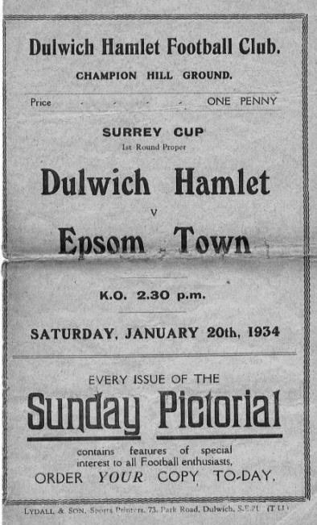
90 years ago this week we hosted Mitcham Wanderers in a League match for the first time at West Street, having edged them out 3-2 in an F.A. Cup tie the previous September. This time we won 2-1 with goals from Reg Marlow and Wilfred ‘Bronk’ Challis and by the time we completed a treble over them in April with a 2-0 win at Streatham Road we were well on our way to registering our first, and only London League title.

84 years ago today we visited the famous Champion Hill ground of Dulwich Hamlet for a Surrey Senior Cup tie. We had visited the earlier Champion Hill in 1931, winning 3-2 that day but this match was at the new ground, just one year old and with enormous attendances that would put a League club to shame. This day there were 8,300 present to witness a bit of a walkover as the Hamlet were clearly set on revenge and defeated us 3-0. (see programme pictured)

60 years ago this week we welcomed Maidenhead United for a Corinthian League Memorial Shield match, with the memory of the previous season’s 2-0 final defeat still on our minds. We had been unlucky that day to lose leading striker Johnny Bangs to a cut for a large part of that match but gained a little revenge with a 5-0 win this day, and Bangs scored three of them, aided by Dave Hermitage and Peter Freeman. Unfortunately the run would end in the Semi-Final at new boys Yiewsley, who would have much success and eventually become better known as Hillingdon Borough.

40 years ago this week we were at home to Eastbourne United in an important Fourth Round tie in the F.A. Vase. It was the first time we had reached the last 32 since our Wembley appearance three years previously and we went into the match with confidence, having not conceded a goal in the competition and with the knowledge of a 4-1 League win at their ground just two weeks previously.

It’s really not clear what went wrong that day, but we just never got going and trailed at the half before losing 3-0 in the end. New signing, the former Football League player Joe Fascione made his debut that day, but just succeeded in getting himself sent off at the end of the match! We’d have to wait eleven years before reaching this stage again, although did have some success in the F.A. Trophy in between.

30 years ago this week we made the short journey to Imber Court for an Isthmian League Division Two South match. The Police side were very good and had only lost one match all season, which came at our hands on the opening day of the season by a score of 4-3 after being in the lead for all of twenty seconds in the match! This day we managed a draw too with a second half equaliser by Simon Ireland on his debut. He didn’t stay long though and this was the only goal he scored for us.

Combined Counties League Premier Division
Opponents All-time Records
inc Tuesday  16th January | P | W | D | L | F | A | PPG | GD | Best  Win | Worst  Loss
Abbey Rangers | 4 | 3 | 0 | 1 | 11 | 4 | 2.25 | +7 | 7-1 | 2-3
Sutton Common Rovers | 14 | 9 | 3 | 2 | 30 | 19 | 2.14 | +11 | 4-0 | 0-5
Horley Town | 32 | 21 | 5 | 6 | 71 | 37 | 2.13 | +34 | 6-0 | 1-3
Spelthorne Sports* | 8 | 5 | 2 | 1 | 16 | 11 | 2.13 | +5 | 6-2 | 1-5
Banstead Athletic | 38 | 23 | 7 | 8 | 62 | 38 | 2.00 | +24 | 5-0 | 0-4
Godalming Town | 3 | 2 | 0 | 1 | 4 | 5 | 2.00 | -1 | 2-1 | 0-3
Bedfont Sports | 12 | 7 | 2 | 3 | 21 | 19 | 1.92 | +2 | 5-1 | 0-7
Colliers Wood United | 24 | 14 | 2 | 8 | 47 | 39 | 1.83 | +8 | 4-0 | 0-5
Farnham Town | 17 | 9 | 4 | 4 | 30 | 25 | 1.82 | +5 | 3-0 | 1-4
Guildford City | 19 | 11 | 1 | 7 | 36 | 25 | 1.79 | +11 | 5-1 | 1-5
Knaphill | 9 | 5 | 1 | 3 | 19 | 15 | 1.78 | +4 | 4-0 | 2-6
Westfield | 22 | 12 | 3 | 7 | 43 | 41 | 1.77 | +2 | 6-1 | 0-5
Walton & Hersham | 53 | 25 | 11 | 17 | 105 | 101 | 1.62 | +4 | 8-0 | 1-9
Hanworth Villa | 18 | 8 | 5 | 5 | 39 | 28 | 1.61 | +11 | 5-0 | 1-4
Camberley Town** | 91 | 38 | 23 | 29 | 159 | 126 | 1.52 | +33 | 9-1 | 0-4
Redhill | 35 | 14 | 2 | 19 | 63 | 77 | 1.26 | -14 | 7-2 | 2-8
Chertsey Town | 51 | 19 | 5 | 27 | 77 | 95 | 1.22 | -18 | 3-0 | 0-7
North Greenford United | 13 | 4 | 2 | 7 | 19 | 24 | 1.08 | -5 | 3-0 | 1-4
AFC Hayes | 11 | 2 | 3 | 6 | 18 | 20 | 0.82 | -2 | 7-0 | 0-3
CB Hounslow United | 4 | 1 | 0 | 3 | 6 | 11 | 0.75 | -5 | 2-0 | 1-5
Balham | 1 | 0 | 0 | 1 | 0 | 4 | 0.00 | -4 | x | 0-4
* includes one loss on penalties v Spelthorne and one win on penalties v Sutton Common Rovers
** includes one abandoned match v Camberley

Buildbase F.A. Vase
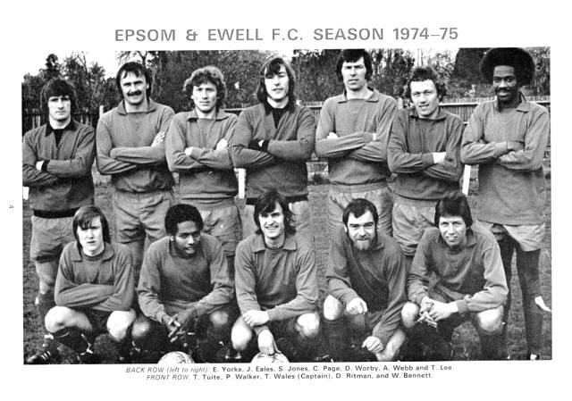

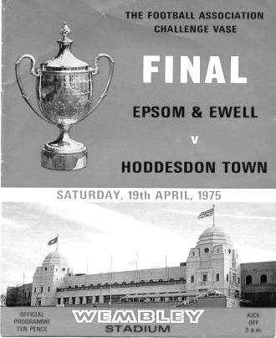
Fourth Round –6th January
Newcastle Benfield | 1-1+ r1-1+ p2-4 | Coleshill Town
Wisbech Town | 1-3 | Bromsgrove Sporting
Cogenhoe United | 2-3 | Wolverhampton SC
Marske United | 5-0 | Hinckley AFC
1874 Northwich | 3-1 | Pontefract Collieries
Stockton Town | 2-1+ | West Auckland Town
Desborough Town | 2-4+ | Stourport Swifts
Melksham Town | 2-1 | Crowborough Athletic
Westfields | 1-4 | Hamble Club
Blackfield & Langley | 3-3+ r1-2 | Bracknell Town
Leighton Town | 5-2+ | Norwich CBS
Newport (IW) | 0-1 | Bradford Town
Eastbourne Town | 1-3 | Windsor
Horley Town | 1-2 | Chichester City
Tring Athletic | 5-1 | Hullbridge Sports
Thatcham Town | 2-1 | Biggleswade
Fifth Round Draw – 3rd February
Wolverhampton SC | V | Leighton Town
Thatcham Town | V | Bromsgrove Sporting
Marske United | V | Bradford Town
Coleshill Town | V | Bracknell Town
1874 Northwich | V | Chichester City
Stockton Town | V | Stourport Swifts
Windsor | V | Hamble Club
Melksham Town | V | Tring Athletic

EL Records Premier Challenge Cup
Quarter-Finals
Godalming Town | 6/2 | Knaphill
Spelthorne Sports | 6/2 | Walton & Hersham
Sutton Common Rovers | 22/1 | Cobham
Worcester Park | 3/2 | Colliers Wood United

Surrey Senior Cup
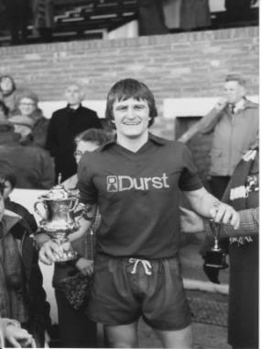
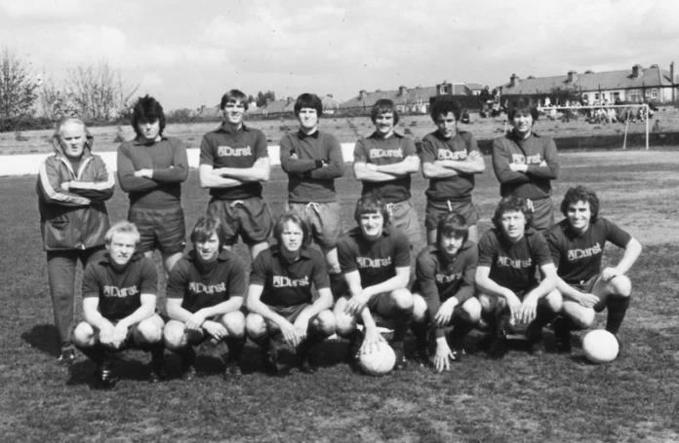

Preliminary Round
Westfield | 3-2 | Abbey Rangers
Dorking Wanderers | 4-1 | Walton Casuals
Knaphill | 1-2 | Met Police
First Round
Westfield | 2-2 - 4-2p | Camberley Town
Woking | 1-3 | Chipstead
Chertsey Town | 1-2 | Spelthorne Sports
Dorking Wanderers | 4-1 | Godalming Town
Horley Town | 0-2 | Kingstonian
AFC Croydon Athletic | 1-5 | Met Police
Tooting & Mitcham United | 1-0 | Corinthian Casuals
Carshalton Athletic | 6-2 | Egham Town
Croydon | 2-2 - 11-12p | Molesey
Farnham Town | 2-2 - 5-4p | Whyteleafe
Sutton United | 2-1 | Redhill
Banstead Athletic | 2-5 | Leatherhead
Sutton Common Rovers | 0-0 – 4-5p | Epsom & Ewell
Guildford City | 2-2 - 3-5p | Colliers Wood United
Merstham | 3-0 | Walton & Hersham
South Park | 2-2 - 4-2p | Ashford Town (Mx)
Second Round
Leatherhead | 24/1 | Kingstonian
Epsom & Ewell | 0-5 | Merstham
Farnham Town | 0-3 | Met Police
Westfield | 2-3 | Colliers Wood United
Spelthorne Sports | 23/1 | South Park
Sutton United | 7-1 | Molesey
Chipstead | 3-2 | Tooting & Mitcham United
Dorking Wanderers | 2-1 | Carshalton Athletic

First Eleven Appearances 2017/18 - (max 31)
Name | Debut | 2017/18 |  |  |  | Career Totals
Name | Debut | App | Sub | Total | Goals | App | Sub | Total | Goals
AJAYI Tayo | 06/08/2017 | 3 | 4 | 7 | 1 | 3 | 4 | 7 | 1
BROOKS Jordan* | 06/08/2017 | 3 | 0 | 3 | 0 | 3 | 0 | 3 | 0
BURROWES Joshua* | 02/12/2017 | 1 | 1 | 2 | 0 | 1 | 1 | 2 | 0
CASTELL Cristian* | 06/08/2017 | 2 | 4 | 6 | 0 | 2 | 4 | 6 | 0
CONNELLY Lloyd | 14/10/2017 | 16 | 2 | 18 | 2 | 16 | 2 | 18 | 2
DEWAR Ali | 29/10/2011 | 1 | 2 | 3 | 0 | 56 | 42 | 98 | 10
DOBRAJ Endrit | 18/11/2017 | 5 | 3 | 8 | 0 | 5 | 3 | 8 | 0
DYSON Ben | 12/08/2017 | 22 | 4 | 26 | 1 | 22 | 4 | 26 | 1
FRANKLIN Ben | 03/03/2015 | 2 | 1 | 3 | 0 | 3 | 1 | 4 | 0
GRAHAM Bentley | 09/02/2016 | 3 | 0 | 3 | 0 | 20 | 1 | 21 | 3
GRANDISON Kane | 11/11/2017 | 7 | 1 | 8 | 0 | 7 | 1 | 8 | 0
GRIFFIN Reisse | 08/08/2015 | 19 | 0 | 19 | 1 | 92 | 13 | 105 | 7
HARLAND-GODDARD Tom* | 06/08/2017 | 1 | 1 | 2 | 0 | 1 | 1 | 2 | 0
HARRIS Colin* | 04/08/2012 | 9 | 0 | 9 | 0 | 34 | 0 | 34 | 0
HATFIELD Jamie | 11/11/2006 | 9 | 1 | 10 | 0 | 258 | 14 | 272 | 6
HAYWARD Ben | 07/03/2007 | 5 | 1 | 6 | 0 | 248 | 29 | 277 | 18
HEAGNEY Adam | 16/08/2016 | 16 | 2 | 18 | 0 | 53 | 11 | 64 | 1
HENDRY Rob | 08/08/2015 | 15 | 1 | 16 | 5 | 83 | 23 | 106 | 28
HOUGH Kyle | 14/08/2007 | 10 | 2 | 12 | 6 | 343 | 21 | 364 | 207
JASPER Joe* | 11/11/2017 | 0 | 1 | 1 | 0 | 0 | 1 | 1 | 0
JEANNOEL Germaine | 02/12/2017 | 2 | 4 | 6 | 1 | 2 | 4 | 6 | 1
KENNEDY Calum | 18/11/2017 | 2 | 1 | 3 | 0 | 2 | 1 | 3 | 0
LAW Franky* | 06/08/2017 | 3 | 0 | 3 | 0 | 3 | 0 | 3 | 0
LOFTUS-CHEEK Joe | 06/08/2017 | 10 | 3 | 13 | 2 | 10 | 3 | 13 | 2
MARKS Samuel | 06/01/2018 | 1 | 2 | 3 | 0 | 1 | 2 | 3 | 0
MARVELL Dale* | 15/01/2000 | 17 | 2 | 19 | 0 | 286 | 51 | 337 | 86
MASTERSON Shaun | 25/11/2017 | 2 | 2 | 4 | 0 | 2 | 2 | 4 | 0
MCKAY Alex | 20/12/2008 | 17 | 1 | 18 | 1 | 148 | 38 | 186 | 13
MOHAMMED Mohammed* | 23/12/2017 | 3 | 0 | 3 | 0 | 3 | 0 | 3 | 0
MULLINGS Corey | 23/12/2017 | 0 | 2 | 2 | 0 | 0 | 2 | 2 | 0
MURPHY George | 19/03/2013 | 2 | 0 | 2 | 0 | 70 | 7 | 77 | 3
MURPHY Scott | 20/01/2007 | 18 | 0 | 18 | 0 | 30 | 2 | 32 | 1
MYERS Antony | 23/12/2006 | 1 | 0 | 1 | 0 | 76 | 33 | 109 | 9
NICHOLAS Kyen | 13/01/2018 | 2 | 0 | 2 | 1 | 2 | 0 | 2 | 1
NWACHUKWU Jason* | 01/10/2016 | 9 | 4 | 13 | 2 | 26 | 20 | 46 | 3
O'BRIEN Louis* | 28/08/2017 | 1 | 3 | 4 | 0 | 1 | 3 | 4 | 0
PINDER Marlon | 13/01/2018 | 1 | 0 | 1 | 1 | 1 | 0 | 1 | 1
ROBERTS Liam | 12/08/2017 | 15 | 8 | 23 | 4 | 15 | 8 | 23 | 4
ROBINSON Sam* | 22/10/2011 | 5 | 0 | 5 | 0 | 66 | 6 | 72 | 14
ROSE Daniel* | 25/10/2016 | 14 | 2 | 16 | 1 | 16 | 7 | 23 | 1
SMITH Andy* | 25/08/2017 | 2 | 0 | 2 | 0 | 2 | 0 | 2 | 0
SMITH Taryn | 28/10/2017 | 7 | 1 | 8 | 0 | 7 | 1 | 8 | 0
STEW-LEWIS Noah | 09/12/2017 | 4 | 1 | 5 | 0 | 4 | 1 | 5 | 0
THOMPSON Ashley | 21/08/2017 | 21 | 1 | 22 | 3 | 21 | 1 | 22 | 3
THOMSON David* | 02/09/2017 | 2 | 2 | 4 | 0 | 2 | 2 | 4 | 0
TURPIE Ali | 31/03/2016 | 1 | 0 | 1 | 0 | 12 | 1 | 13 | 0
WHITE Sean | 02/08/2014 | 14 | 7 | 21 | 2 | 20 | 20 | 40 | 5
YOUNG Conor | 07/03/2015 | 16 | 0 | 16 | 0 | 17 | 0 | 17 | 0
* Player has left the club
Centre page for results

Centre page for results




CCL Premier Division Club Directory
ABBEY RANGERS Telephone: 01932-422962 - Colours: Black & White Stripes/Black/Black
Ground: Addlestone Moor, Addlestone. KT15 2QH

A.F.C. HAYES Telephone: 0208-845-0110 - Colours: Blue and White Stripes/Blue/Blue
Ground: Farm Park, Kingshill Avenue, Hayes. UB4 8DD

BALHAM Telephone: 0208-942 8062 - Colours: White & Black/Black/Black

Ground: Colliers Wood United FC - Wibbandune, Robin Hood Way, Wimbledon. SW20 0AA -

BANSTEAD ATHLETIC Telephone: 01737-350982 - Colours: Amber &Black/Black/Black
Ground: Banstead Athletic, Merland Rise, Tadworth. KT20 5JG

BEDFONT SPORTS Telephone: 0208-831-9067 - Colours: Red & Black Hoops/Black/Red & Black
Ground: Bedfont Sports Club, Hatton Road, Bedfont. TW14 8JA

CAMBERLEY TOWN Telephone: 01276-65392 Colours: Red & White Stripes/Blue/Red
Ground: Krooner Park, Wilton Road, Camberley. GU15 2QW

CB HOUNSLOW UNITED Telephone: 0208-577 -9712 Colours: Green/Black/Green
Ground: CB Hounslow Sports Ground, Green Lane, Hounslow TW4 6DH

CHERTSEY TOWN Telephone: 01932-561774 - Colours: Royal Blue & White Stripes/ Blue/ Blue
Ground: Alwyns Lane, Chertsey. KT16 9DW

COLLIERS WOOD UNITED Telephone: 0208-942 8062 - Colours: Royal Blue/Black/Black
Ground: Wibbandune, Robin Hood Way, Wimbledon. SW20 0AA

EPSOM & EWELL Telephone: 01737-553250 - Colours: Royal Blue & White Hoops/Royal Blue/Royal Blue - Ground: Chipstead FC, High Road, Chipstead. CR5 3SF

FARNHAM TOWN Telephone: 01252-715305 - Colours: - Claret & Sky Blue /White/ Claret & Blue
Ground: Memorial Ground, Babbs Mead, West Street, Farnham. GU9 7DY

GODALMING TOWN Telephone: 01483-417520 - Colours: Yellow/Green/Yellow
Ground: Wey Court, Meadrow, Godalming. GU7 3JE

GUILDFORD CITY Telephone: 01483-443322 - Colours: Red & White Stripes/Black/Black
Ground: The Spectrum, Parkway, Guildford, Surrey. GU1 1UP

HANWORTH VILLA Telephone: 0208-831-9391 - Colours: Red & White Stripes/Black/Black
Ground: Rectory Meadows, Park Road, off Hounslow Road, Hanworth. TW13 6PN

HORLEY TOWN Telephone: 01293-822000 - Colours: Claret & Sky Blue/Claret/Claret
Ground: The New Defence, Anderson Way, Court Lodge Road, Horley. RH6 8SP

KNAPHILL Telephone: 01483-475150 - Colours: Red/Black/Red & Black
Ground: Brookwood Country Park, Redding Way, Lower Guildford Road, Knaphill. GU21 2AY

NORTH GREENFORD UNITED Telephone: 0208 422 8923 - Colours: Royal Blue & White/Royal Blue/Royal Blue - Ground: Berkeley Fields, Berkeley Avenue, Greenford, Middx UB6 0NX

REDHILL Telephone: 01737-762129 - Colours: Red and White Stripes/Red/Red
Ground: Kiln Brow, Three Arch Road, Redhill. RH1 5AG

SPELTHORNE SPORTS Telephone: 01932-961055 - Colours: Navy & Sky Blue/ Blue/ Blue
Ground: Spelthorne Sports Club, 296 Staines Road, Ashford Common, Ashford. TW15 1RY

SUTTON COMMON ROVERS Telephone: 0208-644-4440 - Colours: Yellow/ Yellow / Yellow
Ground: Sutton United FC, Gander Green Lane, Sutton. SM1 2EY

WALTON & HERSHAM Telephone: 01932-245263 - Colours: Red & White Trim/Red/Red
Ground: Stompond Lane, Walton on Thames. KT12 1HF

WESTFIELD Telephone: 01483-771106 - Colours: Yellow/Black/Black
Ground: Woking Park, Kingfield Road, Woking. GU22 9BA

Club History – Balham F.C.
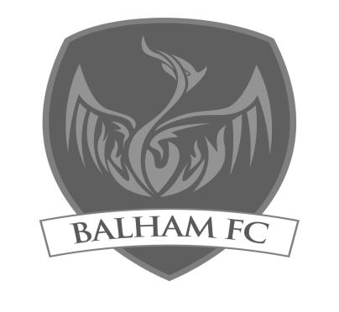
Balham FC was formed in 2011 in order to provide player progression into open age football for the hugely talented, high achieving age group teams of Balham Blazers FC, which was founded by Greg Cruttwell in 2001. Having won back-to-back promotions in 2011/12 and 2012/13, Balham did the league and cup double in the Surrey South Eastern Combination in 2013/14.

In 2014/15 Balham finished in a promotion position again, in the Surrey Elite Intermediate Football League, however promotion was denied due to Combined Counties League facility requirements not being met. Having moved to ground share with Cobham FC, in order to meet the facility requirements, Balham finished as runners up in the SEIFL in 2015/16 and as a result were promoted to Division One of the Combined Counties League for the 2016/17 season.

The club had an exceptional first league campaign at Step 6, finishing in a promotion position for the sixth consecutive season and winning the London Senior Trophy.

In 2017/18 Balham will be playing at Step 5 in the CCL Premier Division. Having begun on Wimbledon Extension, before moving to Cobham, Balham are currently ground sharing with Colliers Wood United at their Wibbandune Stadium.

Latest Result Grid
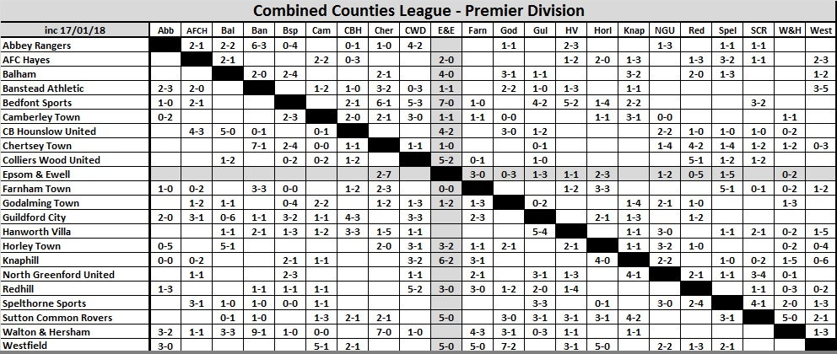

Every Opponent A-Z
Over the years we have played many, many different opponents. Exactly how many is a difficult question, as it all depends on your definition. Are Camberley & Yorktown different to Camberley Town, or are Epsom Town different to Epsom F.C. or Epsom & Ewell F.C.?

In my analysis I have classed them as the same team, and will work through them all from A to Z. Some we have played many times, whilst others we have met maybe just once or twice. Enjoy!


Wingate: Played 16 - W5 D5 L6 - F27 A32 - PPG - 1.25 - Below Average

The story of Wingate FC is a very complicated one. Founded in 1946 they were named after Orde Wingate, a British Army Officer who was famous for creation of the Chindit deep-penetration missions in Japanese held Burma during World War Two; a war he unfortunately failed to survive after being killed in an Aircraft accident in 1944. They were a Jewish club playing at Hall Lane in Hendon and they made their way through the Middlesex Senior, Parthenon and then the London League for ten years before joining the Delphian League in 1962. When that merged with the Corinthian and Athenian Leagues in 1963 we were placed a division above them, but relegation in 1965 threw the teams together, where we would remain for eight seasons.

Our first meeting came on Saturday 5th March 1966 at West Street and we trailed at the half but recovered to win 4-1 with two goals from Peter Scott, one from Alan Cox and the other from future England Amateur International Peter Deadman and on our first visit we secured a 1-1 draw.

The following season we nearly didn’t meet as our club had been under a warning for its disciplinary record and on 9th December 1966 the Surrey F.A. suspended us indefinitely! This took effect from the following Monday but by that Friday, Chairman George Tarran had attended an appeal and we were reinstated. The following day we went to Wingate and led 2-1 at the half, extending this into a bizarre 7-5 victory. We have only had one other first team match since then with 12 goals and bearing in mind our issues at the time, the local Press described this match as a team of rabbis (Wingate) against a team of vicars, such was the cleanliness of the match!

Unfortunately we let a 2-1 lead turn into a 2-3 defeat at home in the February return, although we registered an away draw and a 3-1 home win with a Johnny Eales hat trick the following season.

From that point onwards though, results took a turn for the worse. Obviously we were not a good team around this time but from 1968/69 we would register just three draws from the next eight matches, including a 0-5 away defeat and a 1-5 home loss in our ill-fated 1970/71 season.

At least in our final Athenian League season of 1972/73 we were able to secure our first League double over them with 2-1 and 3-1 wins, but we still finished second from bottom of the League albeit ahead of Wingate! Despite this, it was our club that were rejected by the League and we went to the Surrey Senior League where it all started to happen again for us.

However, all was not well at Wingate either. The 1972/73 season had been played at a number of venues as Hall Lane had been requisitioned by the Ministry of Transport and it now sits under the M1 Motorway, approximately one and a half miles north of Junction 1! Our League match that season took place at Brickfield Lane in nearby Arkley and their very future was under threat.

Wingate found salvation at Summers Lane, home of Finchley, where they remained until 1975 when they merged with the famous old Leyton club and became Leyton Wingate for a while, playing out of the Hare and Hounds ground in Lea Bridge Road.

We met the Leyton Wingate club on a couple of occasions during 1975/76 and again in1986/87, but I’ve covered these matches earlier. This is where it gets really confusing though as many at the club were not happy with the merger and re-constituted the old club name in 1984.

We defeated them in a London Challenge Cup tie in 1991 at West Street and the old Leyton Wingate name continued until 1992 when Wingate was removed from the name and they became Leyton once again before further name changes resulted in them becoming Waltham Forest. A new Leyton club followed in 1997 and reclaimed the original name, but then folded suddenly in January 2011 under a bit of a cloud (VAT fraud) and the second oldest club name in London was wiped from the list.

Wingate though, had better luck. The newly reformed club threw in their lot back at Summers Lane, which was refurbished and renamed the Harry Abrahams Stadium. Nowadays known as Wingate & Finchley they hold their place in the Isthmian League Premier Division currently, although it took them a while to get there and on their way up the leagues we met for seven seasons until our promotion in 2002. Considered as a continuation of the Finchley club, I included their results together many years ago when I was covering clubs beginning with F, although I can always make room for their wonderful Art Deco 1930 vintage stand (below). A lesser known stand was that at Hall Lane which disappeared in 1972 and that is shown lower down here.

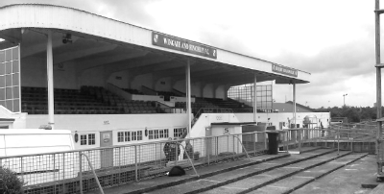
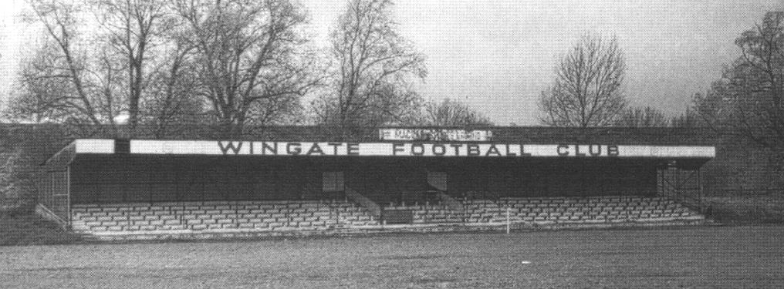

Player Sponsorship
Here is the latest list for 2017/18, with new photos showing all of our players and Management that are available for sponsorship. Other new players will be added as and when they arrive!

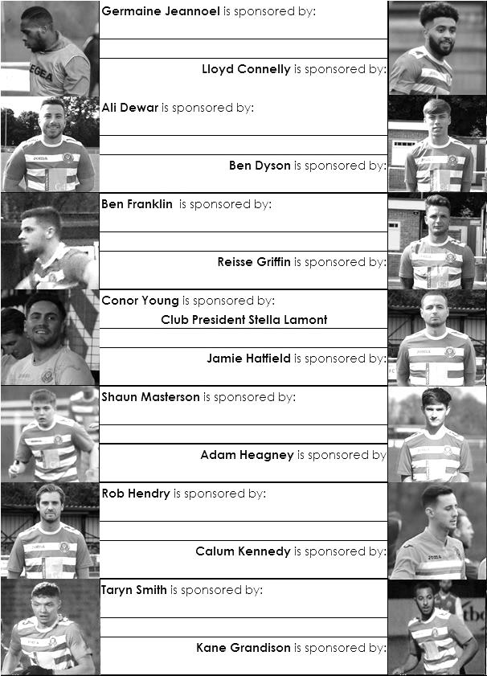

Sponsorship costs just £40 and it is easy to do. Just select a player who has not been previously sponsored and let a Committee Member know. Beware though. Until we have received the money it is possible for someone to jump in front of you, so don’t delay, sponsor today!

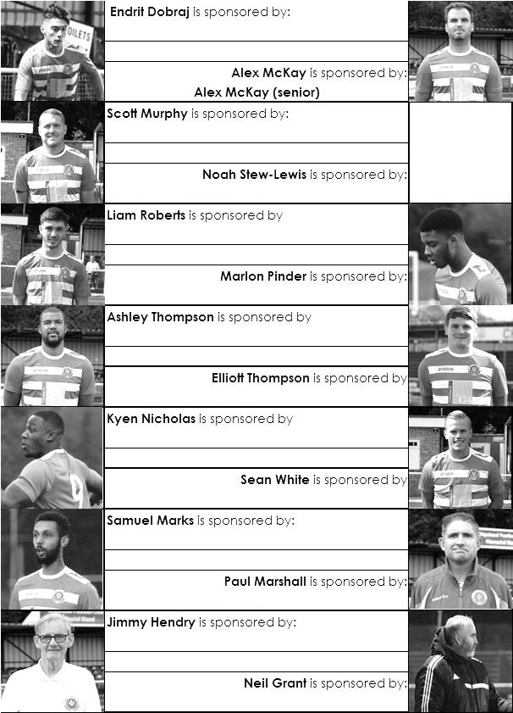

Match and Ball Sponsorships – 2017/18
Opponent | Date | Match Sponsor | Ball Sponsor
Banstead Athletic (FAC) | 06/08/17 | Club President - Stella Lamont
Chertsey Town | 15/08/17 | EEFC Management Committee
Redhill | 02/09/17 | Building Shop Ltd
Spelthorne Sports | 09/09/17 | In memory of Betty Dyke
Horley Town | 12/09/17 | Alex McKay (Senior)
Hanworth Villa | 23/09/17 | Jack Jarman
North Greenford United | 28/10/17 | Marvin and Kathy Hough
Farnham Town | 14/11/17 | In memory of Dave and Lizzie Marshall
Godalming Town | 21/11/17 | Building Shop Ltd
Guildford City | 02/12/17 | John Bonner
Walton & Hersham | 30/12/17 | Jeff and Arnold Pye
Merstham (SSC) | 16/01/18 | Paul Merritt
Balham | 20/01/18
Abbey Rangers | 23/01/18 | Pete Beddoe’s grandchildren  George, Joseph, Ezara & Inaya
Sutton Common Rovers | 03/02/18 | David Ellins
CB Hounslow United | 13/02/18
Knaphill | 24/02/18
Camberley Town | 10/03/18
Bedfont Sports | 24/03/18
Colliers Wood United | 30/03/18
Banstead Athletic | 02/04/18 | Nathan Lambert – 10 years old today!
Westfield | 14/04/18
AFC Hayes | 28/04/18 | Club President - Stella Lamont
Match sponsorship costs just £60.00!

Sponsorship includes:

Admission, programmes and hospitality for three people.

A full page advert in the programme and mascot for the day (if required).

Also, you get to choose the player of the match, who will receive a prize

If you are interested, just speak to a Committee Member,
or drop me an email at: richard.c.lambert@gmail.com

Salts Super Six Predictor
The Salts Super Six Predictor jackpot is sitting at £206 for today’s match. The tickets are on sale at today’s game to the left of the gate. The matches on the ticket are to be played today!

The competition is easy to play! To win, you simply need to predict the results of six matches correctly from the three options, fill in the form and make sure it is back with our seller before the deadline on the ticket. The latest fixtures are shown below.

If you are a club regular, you just need to place your name on the sheet, although if you aren’t, then we’ll need a contact number from you too. We will announce any winners on the website within three working days, so don’t worry, we won’t miss you!

Please note that if there is more than one winner, the prize pot would be shared between the winners. All you need to do now is have a go, as many times as you like!

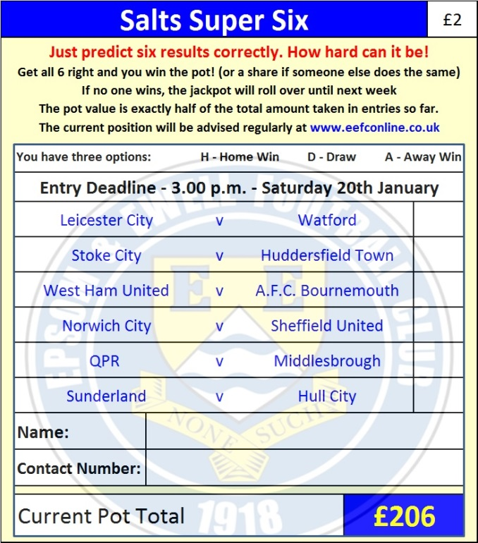
Good luck!

Combined Counties League – Premier Division
Saturday, 20th January 2018 - Kick-off 3.00 p.m.
Epsom and Ewell  (Royal Blue & White hoops) | V |  | Balham  (Black and White)
Squad | NUMBERS |  | Squad
Conor Young |  |  | James Adebayo
Noah Stew-Lewis |  |  | Josh Benson
Endrit Dobraj |  |  | Jerome Boncoeur
Adam Heagney |  |  | Dan David
© Alex McKay |  |  | Nacho Diaz
Ashley Thompson |  |  | Marco Erriu
Marlon Pinder |  |  | Luke Fenlon
Scott Murphy |  |  | Thomaas Fosse
Kyen Nicholas |  |  | Hamish Frew
Rob Hendry |  |  | James Fuller
Lloyd Connelly |  |  | Julian Fuller
Samuel Marks |  |  | James Gallagher
Ben Dyson |  |  | Elliot Garcia
Liam Roberts |  |  | Elliott Gibbs
Ali Turpie |  |  | Grant Goodband
Germaine Jeannoel |  |  | Steve Harman
Ben Franklin |  |  | Jake Henry
Shaun Masterson |  |  | Jonathan Lewes
Kane Grandison |  |  | Eddie Luchford
Calum Kennedy |  |  | Michael McConnell
Troy Williams |  |  | Michael Neish
Reisse Griffin |  |  | Darren Nolan
Taryn Smith |  |  | Anis Nuur
Ali Dewar |  |  | Ibrahim Olutade
Neil Grant | MANAGER |  | Greg Crutwell
Alex McKay | ASSISTANT |  | Ollie Kanner / James Scott
Jordan Clark / Jimmy Hendry | COACH / PHYSIO |  | Ebrahi, Seedat / Pedro Soares
REFEREE: A.Thomson
ASSISTANTS: W.Ingram, K.Parker

OUR NEXT VISITORS TO HIGH ROAD
Abbey Rangers
Cherry Red Combined Counties League – Premier Division
Tuesday 23rd January 2018 – 7.45 p.m.

